Fairy Tale or Fable Book Report

Directions
- Choose a Fairy Tale, Tall Tale or Fable to read on your own or with your parents help. Approve the book with Mrs. Landon
- After you have read the book fill out the book report paper.
- Make a map of the setting from your book. Imagine what the homes or castles look like. Maybe there is a lake or river in your story. Where did your story take place? Did it take place in a forest, desert, country, or a small town?
- Include the following on your map
- Name of your setting. For example Sleeping Beauty’s Forest
- Key (Here are some ideas) and a compass rose.
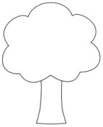=forest
=mountains =river or lake
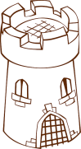= castle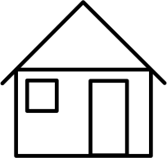=home
3. Include at least 4 details of the setting on your map.
4. Color your map.

