A fairy tale is a story that...
... contains magic
... has good and evil characters
... usually includes royalty or castles
... has a problem and a solution
... has events that usually happen in threes or seven.
Fairy tales also have beginning and ending words like...
"Once upon a time...." or "They lived happily ever after."

.
Directions:
- Choose a Fairy tale or Fable. If it is not on the school list ask Mrs. Landon for approval.
- Read the book
Then...
- 1.Write a Book Report for the Fairy Tale you read.
AND
- 2. Make a puppet of your favorite character in the story.
... You can use a paper bag or a sock to make your puppet.
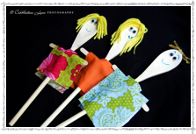
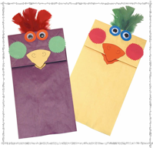
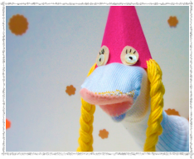
Here are some examples of what some of these puppets could look like.
Other Ideas for Puppets

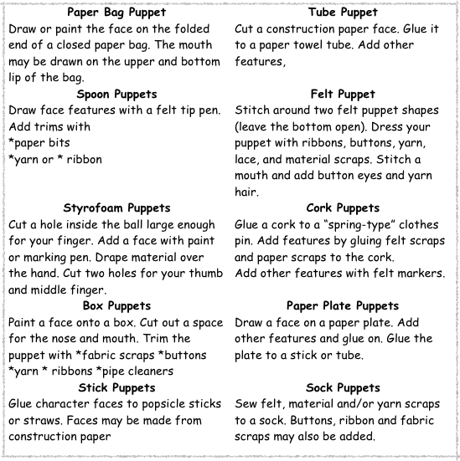

Tt

Name____________________________ Date___________________
FAIRY TALE or FABLE BOOK REPORT
Fairy Tale OR FABLE NAME: _______________________________________________
Author: ________________________________________________________________
Illustrator: _______________________________________________________________
Setting
________________________________________________________________________
________________________________________________________________________
Main Characters
________________________________________________________________________
________________________________________________________________________
What was the conflict or problem in this fairy tale or fable?
_________________________________________________________________________
_________________________________________________________________________
What did the main character have to do in order to overcome the
problem?
_________________________________________________________________________
_________________________________________________________________________
_________________________________________________________________________
Conclusion: How did the fairy tale or fable end?
_________________________________________________________________________
__________________________________________________________________________________________________________________________________________________

