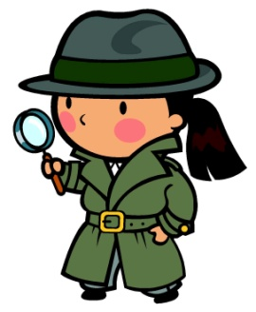
Title of book__________________________________________________________________
Author_____________________________________________________________________________
This book was (Easy, just right, hard) Circle one # of pages_____________

Who are the Main Characters?
_____________________________________________________________________________________________________________________________________________________________________________________________________________________________________________________________________________What is the problem the character(s) has to solve?
__________________________________________________________________________________________________________________________________________________________________________________________________________________________________________________________________________________________________________________________________________________________________________________________________________________________________________________________________What is the setting in the book
______________________________________________________________________________________________________________________________________________________________________________________________________________________________________________________________________________________________________________________________________________________________________

describe 3 clues that helped them solve the mystery
1)____________________________________________________________________________________________________________________________________________________________________________________________________________________________________________________________________________ 2)____________________________________________________________________________________________________________________________________________________________________________________________________________________________________________________________________________ 3)____________________________________________________________________________________________________________________________________________________________________________________________________________________________________________________________________________How was the mystery solved? What happened at the end of the story?
__________________________________________________________________________________________________________________________________________________________________________________________________________________________________________________________________________________________________________________________________________________________________________________________________________________________________________________________________Were you surprised by the ending? Use a complete sentence
_____________________________________________________________________________________________________________________________________________________________________________________________________________________________________________________________________________

